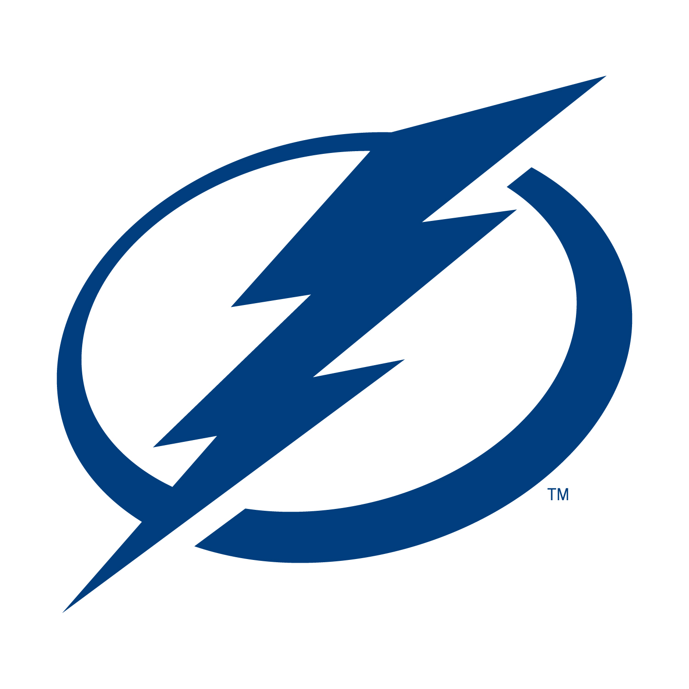

Tampa Bay Lightning – GAME NOTES

Tampa Bay Lightning vs. Nashville Predators
Saturday, September 30, 2023
AMALIE Arena
Tampa, FL

TAMPA BAY VS. CAROLINA: ALL-TIME
ALL-TIME ALL-TIME RECORD: 22-15-3 with two ties
LAST REGULAR SEASON GAME: December 8, 2022 at AMALIE Arena (Tampa Bay 5, Nashville 2)
FIRST REGULAR SEASON MEETING: October 10, 2023 at AMALIE Arena

2023 PRESEASON RESULTS AND UPCOMING SCHEDULE
GAME | DATE | RESULT |  |  | OPPONENT |  | SITE | TIME
PS1 | Sept. 26 | 5-2, L |  |  | at Carolina |  | PNC Arena | 7 p.m.
PS2 | Sept. 27 | 2-1, OTW |  |  | at Nashville |  | Bridgestone Arena | 8 p.m.
PS3 | Sept. 29 | 4-0, W |  |  | vs. Carolina |  | AMALIE Arena | 7 p.m.
PS4 | Sept. 30 |  |  |  | vs. Nashville |  | AMALIE Arena | 5 p.m.
PS5 | Oct. 3 |  |  |  | vs. Florida |  | Amway Center | 7 p.m.
PS6  PS7 | Oct. 5  Oct. 7 |  |  |  | vs. Florida  at Florida |  | AMALIE Arena  Amerant Bank Arena | 7 p.m.  6 p.m.
*All Start Times Eastern (ET)

2023 PRESEASON GOAL SCORERS
DATE | OPPONENT | SCORE | 1st | 2nd | 3rd | 4th | 5th | 6th
Sept. 26 | at Carolina |  | Barre-Boulet | Sheary | -- | -- | -- | --
Sept. 27 | at Nashville |  | Groshev | Motte | -- | -- | -- | --
Sept. 29 | vs. Carolina |  | Cirelli | Robert | Cirelli | Glendening | -- | --
Sept. 30 | vs. Nashville |  | -- | -- | -- | -- | -- | --
Oct. 3 | vs. Florida |  | -- | -- | -- | -- | -- | --
Oct. 5  Oct. 7 | vs. Florida  at Florida |  | --  -- | --  -- | --  -- | --  -- | --  -- | --  --

SO – Shootout winner

PS – Penalty shot

2022-23 REGULAR SEASON SCORING

 | Player | Pos | GP | G | A | P | +/- | PIM | PP | SH | GW |  | OT | S | S% | TOI/G | FO%
1 | Nikita Kucherov | R | 82 | 30 | 83 | 113 | -2 | 36 | 8 | 0 | 4 |  | 0 | 271 | 11.1 | 20:08 | 100
2 | Brayden Point | C | 82 | 51 | 44 | 95 | +2 | 7 | 20 | 0 | 9 |  | 1 | 235 | 21.7 | 19:40 | 50.7
3 | Steven Stamkos | C | 81 | 34 | 50 | 84 | -5 | 46 | 14 | 0 | 6 |  | 2 | 240 | 14.2 | 19:01 | 53.8
4 | Brandon Hagel | L | 81 | 30 | 34 | 64 | +23 | 54 | 7 | 1 | 3 |  | 0 | 178 | 16.9 | 18:39 | 28.4
5 | Alex Killorn | L | 82 | 27 | 37 | 64 | +18 | 45 | 3 | 1 | 5 |  | 2 | 143 | 18.9 | 17:13 | 50
6 | Mikhail Sergachev | D | 79 | 10 | 54 | 64 | +13 | 53 | 3 | 0 | 2 |  | 0 | 156 | 6.4 | 23:49 | -
7 | Victor Hedman | D | 76 | 9 | 40 | 49 | +10 | 42 | 1 | 1 | 1 |  | 0 | 185 | 4.9 | 23:43 | -
8 | Nick Paul | L | 80 | 17 | 15 | 32 | +11 | 33 | 4 | 1 | 4 |  | 0 | 120 | 14.2 | 16:10 | 53.8
9 | Ross Colton | C | 81 | 16 | 16 | 32 | -8 | 50 | 4 | 0 | 3 |  | 0 | 153 | 10.5 | 12:21 | 56.1
10 | Anthony Cirelli | C | 58 | 11 | 18 | 29 | +13 | 33 | 1 | 2 | 1 |  | 0 | 111 | 9.9 | 16:34 | 51.4
11 | Corey Perry | R | 81 | 12 | 13 | 25 | -28 | 95 | 6 | 0 | 3 |  | 0 | 116 | 10.3 | 11:34 | -
12 | Nick Perbix | D | 69 | 5 | 15 | 20 | +11 | 22 | 0 | 0 | 2 |  | 0 | 111 | 4.5 | 15:24 | -
13 | Ian Cole | D | 78 | 3 | 14 | 17 | +13 | 61 | 0 | 0 | 0 |  | 0 | 109 | 2.8 | 19:23 | -
14 | Erik Cernak | D | 70 | 2 | 14 | 16 | +8 | 53 | 0 | 1 | 0 |  | 0 | 87 | 2.3 | 19:14 | -
15 | Vladislav Namestnikov | C | 57 | 6 | 9 | 15 | -2 | 19 | 0 | 0 | 0 |  | 0 | 72 | 8.3 | 11:50 | 38.9
16 | Pat Maroon | L | 80 | 5 | 9 | 14 | -5 | 150 | 0 | 0 | 0 |  | 0 | 62 | 8.1 | 10:21 | 16.7
17 | Pierre-Edouard Bellemare | C | 73 | 4 | 9 | 13 | -9 | 34 | 0 | 0 | 0 |  | 0 | 51 | 7.8 | 11:17 | 52.3
18 | Zach Bogosian | D | 46 | 1 | 4 | 5 | -4 | 42 | 0 | 0 | 0 |  | 0 | 54 | 1.9 | 14:59 | 100
19 | Tanner Jeannot | L | 20 | 1 | 3 | 4 | -6 | 22 | 0 | 0 | 0 |  | 0 | 20 | 5 | 11:55 | 55.6
20 | Cal Foote | D | 26 | 1 | 2 | 3 | +3 | 28 | 0 | 0 | 0 |  | 0 | 21 | 4.8 | 14:12 | -
21 | Philippe Myers | D | 11 | 1 | 2 | 3 | 0 | 4 | 0 | 0 | 0 |  | 0 | 21 | 4.8 | 11:33 | -
22 | Darren Raddysh | D | 17 | 1 | 2 | 3 | -4 | 4 | 0 | 0 | 0 |  | 0 | 25 | 4 | 16:29 | -
23 | Mikey Eyssimont | C | 15 | 1 | 1 | 2 | -3 | 22 | 0 | 0 | 0 |  | 0 | 31 | 3.2 | 11:25 | 39.1
24 | Cole Koepke | L | 17 | 1 | 0 | 1 | -5 | 2 | 0 | 0 | 0 |  | 0 | 12 | 8.3 | 9:06 | -
25 | Rudolfs Balcers | L | 3 | 1 | 0 | 1 | +1 | 0 | 0 | 0 | 0 |  | 0 | 3 | 33.3 | 6:53 | -
26 | Haydn Fleury | D | 29 | 0 | 1 | 1 | -10 | 14 | 0 | 0 | 0 |  | 0 | 33 | 0 | 12:48 | -
27 | Gabriel Fortier | L | 1 | 0 | 0 | 0 | 0 | 0 | 0 | 0 | 0 |  | 0 | 0 | - | 8:25 | -
28 | Alex Barre-Boulet | C | 1 | 0 | 0 | 0 | 0 | 0 | 0 | 0 | 0 |  | 0 | 1 | 0 | 10:01 | 0

 | Player | GP | GS | W | L |  | OT | SA | GA | GAA | Sv | Sv% | SO | G | A | PIM | TOI
1 | Andrei Vasilevskiy | 60 | 60 | 34 | 22 |  | 4 | 1875 | 159 | 2.65 | 1716 | .915 | 4 | 0 | 2 | 0 | 3596:25
2 | Brian Elliott | 22 | 22 | 12 | 8 |  | 2 | 689 | 75 | 3.40 | 614 | .891 | 2 | 0 | 1 | 0 | 1324:44

2023 PRESEASON LEADERS

GAMES PLAYED: Bogosian (2), Carlile (2), Chaffee (2), Cirelli (2), Day (2), Eyssimont (2), Fleury (2), Glendening (2), Goncalves (2), Jeannot (2), Motte (2), Myers (2), Robert (2), Sheary (2), Szturc (2), Thompson (2),
GOALS: Barre-Boulet (1), Groshev (1), Motte (1), Sheary (1)
ASSISTS: Eyssimont (2), Raddysh (2), Robert (2), Sheary (2), Thompson (2)
POINTS: Robert (3), Sheary (3)
PENALTY MINUTES: Watson (5)
POWER PLAY GOALS: Barre-Boulet (1), Groshev (1), Motte (1), Robert (1)
GAME-WINNING GOALS: Cirelli (1), Motte (1)
SHOTS: Eyssimont (1)
WINS: Johansson (1), Tomkins (1)

LIGHTNING ALL-TIME PRESEASON RECORD (96-70-13 with 15 ties)

2022 PRESEASON RESULTS

DATE | OPPONENT | SCORE | 1st | 2nd | 3rd | 4th | 5th | 6th
Sept. 27 | at Carolina | 1-5 L | Namestnikov | -- | -- | -- | -- | --
Sept. 28 | vs. Carolina | CANCELLED | -- | -- | -- | -- | -- | --
Sept. 29 | vs. Nashville | CANCELLED | -- | -- | -- | -- | -- | --
Sept. 29 | at Nashville | 0-2 L | -- | -- | -- | -- | -- | --
Sept. 30 | at Nashville | 1-7 L | Hagel | -- | -- | -- | -- | --
Oct. 6 | at Florida | 2-3 L | Paul | Namestnikov | -- | -- | -- | --
Oct. 8 | vs. Florida | 5-2 W | Kucherov | Namestnikov | Namestnikov | Namestnikov | Point | --

2022 PRESEASON LEADERS
GAMES PLAYED: Koepke (5), Colton (4), Hagel (4), Namestnikov (4), Paul (4), Barre-Boulet (3), Cernak (3), Cole (3), Fleury (3), Foote (3), Fortier (3), Hedman (3), Killorn (3), Kucherov (3), Maroon (3), Myers (3), Perry (3), Point (3), Bellemare (2), Day (2), Perbix (2), Sergachev (2), Smith (2), Stamkos (2), Usau (2), Vasilevskiy (2), Alnefelt (1), Carlile (1), Dumont (1), Dureau (1), Edmonds (1), Elliott (1), Feist (1), Finley (1), Goncalves (1), Jones (1), Labrie (1), Lagace (1), MacArthur (1), Mismash (1), Raddysh (1), Ryfors (1), Schmidt (1), Thompson (1), Walcott (1)

GOALS: Namestnikov (5), Hagel (1), Kucherov (1), Paul (1), Point (1)

ASSISTS: Colton (3), Perry (3), Foote (2), Kucherov (2), Fleury (1), Hedman (1), Koepke (1), Namestnikov (1), Point (1), Stamkos (1)

POINTS: Namestnikov (6), Colton (3), Kucherov (3), Perry (3), Foote (2), Point (2), Fleury (1), Hagel (1), Hedman (1), Koepke (1), Paul (1), Stamkos (1)

PENALTY MINUTES: Myers (12), Perry (11), Fleury (8), Foote (8), Finley (5), Maroon (5), Ryfors (5), Namestnikov (4), Cernak (2), Fortier (2), Goncalves (2), Killorn (2), Koepke (2), Kucherov (2), Paul (2), Team (2)

POWER PLAY GOALS: Kucherov (1), Namestnikov (1)

GAME-WINNING GOALS: Namestnikov (1)

SHOTS: Hedman (14), Namestnikov (12), Paul (11), Kucherov (9), Fleury (8), Koepke (8), Point (8), Cole (6), Stamkos (6), Barre-Boulet (5), Hagel (5), Killorn (5), Colton (4), Day (4), Myers (4), Smith (4), Perry (3), Foote (2), Fortier (2), Perbix (2), Walcott (2), Bellemare (1), Dumont (1), Dureau (1), Edmonds (1), Finley (1), Jones (1), Maroon (1), Mismash (1), Raddysh (1), Ryfors (1), Sergachev (1), Thompson (1), Usau (1)

GOALIE STARTS: Vasilevskiy (2), Alnefelt (1), Elliott (1), Lagace (1)

GOALIE WINS: Vasilevskiy (1)

